Exp 5
clc; clear; close;
count=csvRead('C:\scilab projects\user defined functions\count.dat'); for i=1:3
scf(); mu(i)=mean(count(:,i));
sigma(i)=stdev(count(:,i));
histplot(24,count(:,i));
xtitle('roll no=E3159 Histrogram of traffic intersection'+string(i));
end MeanTotal=mean(mean(count));
disp('Mean for individual Traffic intersection is=',mu);
disp('Standard Deviation for individual Trafffic intersection is=',sigma); disp('Overall Mean=',MeanTotal);
Exp 6
Code : clc; clear; close;
exec('C:\scilab_projects\user defined functions\pskmod.sci'); exec('C:\scilab_projects\user defined functions\qammod.sci');
N = 4; // number of bits to be grouped M = 2^N; x = 0:M-1; z = pskmod(x, M); scf(); // create a new figure subplot(1,2,1);
scatter(real(z), imag(z),"fill"); h = gca(); // get current axes
h.data_bounds = [-1.5,1.5,-1.5,1.5];//adjust axes boundries as per need xtitle('E3270 M-ary PSK', 'In-phase', 'Quadrature'); y = qammod(x, M); subplot(1,2,2);
scatter(real(y), imag(y),"fill"); h = gca();
h.data_bounds = [-3.5,3.5,-3.5,3.5];

Exp 7
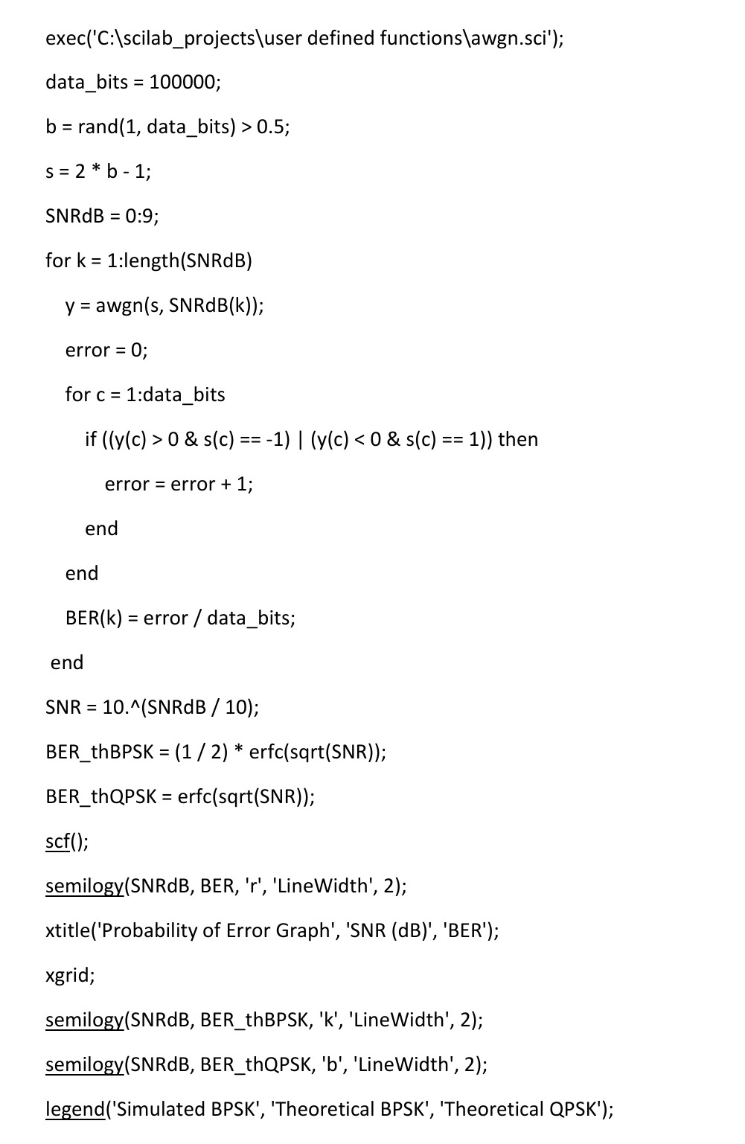

Exp 8
clc;
clear all;
P_XY=input(&#39;enter joint probability matrix &#39;);
[m,n]=size(P_XY);
for i=1:m
px(i)=0;
for j=1:n
px(i)=px(i)+P_XY(i,j);
end
end
disp(&#39;P(X) matrix is:&#39;)
disp(px);
hx=sum(-px.*log2(px));
disp(&#39;Input entropy H(X) is:&#39;)
disp(hx);
for i=1:n
py(i)=0;
for j=1:m
py(i)=py(i)+P_XY(j,i);
end
end
disp(&#39;P(Y) matrix is:&#39;)
disp(py);
hy=sum(-py.*log2(py));
disp(&#39;Output entropy H(Y) is:&#39;)
disp(hy);
h_xy=0;
for i=1:m
for j=1:n
h_xy=h_xy+P_XY(i,j)*log2(1/P_XY(i,j));
end
end
disp(&#39;Entropy H(XY) is:&#39;)
disp(h_xy);
hxby=h_xy-hy;
hybx=h_xy-hx;
Exp 9
clc;
clear;
n = input('* E3142 * Enter the codeword length in LBC (n): ');
k = input('Enter the number of message bits in LBC (k): ');
p = input('Enter the parity matrix ');
g = [eye(k,k)p];
disp('Generator matrix',g);
d = [0 0 0; 0 0 1; 0 1 0; 0 1 1; 1 0 0; 1 0 1; 1 1 0; 1 1 1]
c = modulo(d*g, 2);
disp('all codewords',c);
Hw = zeros(2^k, 1);
for i = 1:2^k
wt = 0;
for j = 1:n
if c(i, j) == 1 then
wt = wt + 1;
end
end
Hw(i) = wt;
end
y = [c, Hw];
disp('code vector with hamming weight',y);
dmin = Hw(2);
for i = 2:2^k
if dmin > Hw(i) then
dmin = Hw(i);
end
end
disp('Minimum Hamming Distance is ',dmin);
td = dmin - 1;
disp('Error Detection Capability of code(in bits) is ',td);
tc = (dmin - 1) / 2;
disp('Error Correctionn Capability of code(in bits) is ', tc);
disp('Transpose of parity matrix is ',p');
H = [p', eye(n - k, n - k)];
disp('Parity check matrix is ',H);
disp('Transpose of parity check matrix is ',H');
r = input('Enter the received codeword');
synd = modulo(r * H', 2);
disp('Syndrome for received codeword is ',synd);
for i = 1:size(H', 1)
if H'(i, 1:n - k) == synd then
r(i) = 1 - r(i);
disp('By matching this syndrome with different rows of Transpose of parity check matrix, Error is at location ',i);
end
end
disp('Corrected codeword is ',r);

Exp 10
clc;
clear;
exec('C:\Users\Amogh Khedekar\Desktop\scilab prog\deconv.sci');
n = input('*E3142* Enter the length of codeword : ');
k = input('Enter the length of message : ');
gen_coff = input('Enter the generator coefficient : ');
m = input('Enter the message : ');
y2 = [1];
a = zeros(1, n - k);
z1 = [y2 a];
x = conv(z1, m);
x1 = pmodulo(x, 2);
[q, r] = deconv(x1,gen_coff);
r1 = [zeros(1, length(x1) - length(r)),r];
codeword = bitxor(x1,r1); //codeword = (x1 & ~r1) | (~x1 & r1);
disp('CYCLIC CODEWORD= ',codeword*1);
rec = input('Enter the received codeword : ');
[q,r] = deconv(rec, gen_coff);
syn = pmodulo(r, 2);
disp('Syndrome for received codeword is:',syn);
if syn == 0 then
disp('No error in received code, No need of correction ');
else
disp('Non zero syndrome indicates Error in received code');
syn = [zeros(1, length(x1) - length(syn)),syn];
y2 = zeros(n, n);
e = eye(n, n);
for i = 1:n
[q, r] = deconv(e(i,:),gen_coff);
r1 = [zeros(1,n - length(r)),r];
y2(i,:) = pmodulo(r1, 2);
end
for i = 1:n
if syn == y2(i,:) then
break
end
end
correctedCode=bitxor(rec,e(i,:));
disp('CORRECTED CODEWORD= ',correctedCode*1);
end

